Title in 14 Point Arial Bold Centered

Name1 A. Surname1 Name2 A. Surname2* Name3 A. Surname3

University of XXX, Dept. of YYYYY, CountryZ *ZZZZ Co., CountryW

Figure 1: Optional figure with one or more frames that may illustrate your work, product, or game. 9 Times New Roman, centered under figure.

Abstract

This meta-paper describes the model to be used in papers and posters for SBGames. In the subsection Authors’ contact, make reference to the same symbol used in the affiliation.

Keywords: image-based rendering, virtual reality, HDR images

Authors’ contact:
{name1,name3}@xxx.yyyy.yyy
*name2@zzzz.vvvv.vvv

1. Introduction

The document specifications are: paper size A4; margins: Top = 2.0 cm, Bottom = 2.5 cm, Left = 2.5 cm, Right = 2.0 cm; 2 columns with Width = 7.85 cm and Spacing = 0.8 cm. You should not number the pages.

The typeface reference of your paper/poster is 10 point Times New Roman, single line spacing, justified. The exceptions are:

- Title (see above)
- Affiliation: 12 point Times New Roman, centered
- Internet addresses and computer codes: 9 point Courier New
- Caption (Figures and Tables): 9 point Times New Roman, centered under figure or table.
- Section Head: 12 point Arial, bold, left aligned, numbered
- Subsection Head: 10 point Arial, bold, left aligned, numbered
- References: 9 point Times New Roman

2. Related Work

It is strongly recommended that your paper has a section named Related Work. This is a tradition in the most important international conferences.

3. General Recommendations

Avoid to leave a section or subsection head isolated in the previous column or page.

Only the first paragraph of a section starts with no tab; any other paragraph starts with a tab of 0.5 cm. Every paragraph and head has a blank line before them. You should avoid writing a subsection immediately after a section head; trying to have at least a sentence explaining the section.

3.1 Citations and References

SBGames citation format is the familiar “author year” format (quite similar to the one used by the SIGGRAPH conferences), also called Harvard notation. Although the Harvard notation uses parentheses, SBGames citation format uses brackets. Detailed information about the Harvard notation can be found elsewhere [Holland 2005].

The Harvard notation can be summarized as follows. The year is separated from the author by a single space. If the article has two authors, their last names are used, separated by the word “and”. If the article has three or more authors, the primary author’s name, followed by “et al.” are used, that is:

[Woodcock 2001], for 1 author;
[Parke and Walters] for two authors;
[Ducheneaut et al. 2006] for two or more authors;

Multiple citations are separated by semicolons: [Ducheneaut et al. 2006; Kartch 2000].

When the name of the author is used in body text, it may be omitted from the citation, leaving the year, for example: “… as shown in Ducheneaut et al. [2006], the …” or “Woodcock [2001] has proposed that …”. When an author has published more than one cited document in the same year, these are distinguished by adding lower case letters (a, b, c, …) after the year, for example: “… contains a series of three articles [Biasillo 2002a; Biasillo 2002b; Biasillo 2002c] that …”.

All references mentioned in the Reference List should be cited in the text, and vice-versa.

The reference list must be unnumbered, alphabetized by primary author’s last name, with the author list set in small caps, followed by the year of publication, followed by other information. The page number, if any, appears last in the reference. The second and successive lines of each entry are indented 0.5cm. Journal, book, thesis, and conference proceeding titles are set in italic type. See examples in the section References below.

2.2 Figures, Images, and Tables

You may have figures crossing the columns. However, large images should be placed at the very end of the paper or poster. You should avoid framing the figure with a visible line (unless the border is part of the figure). Figure 2 illustrates this situation.
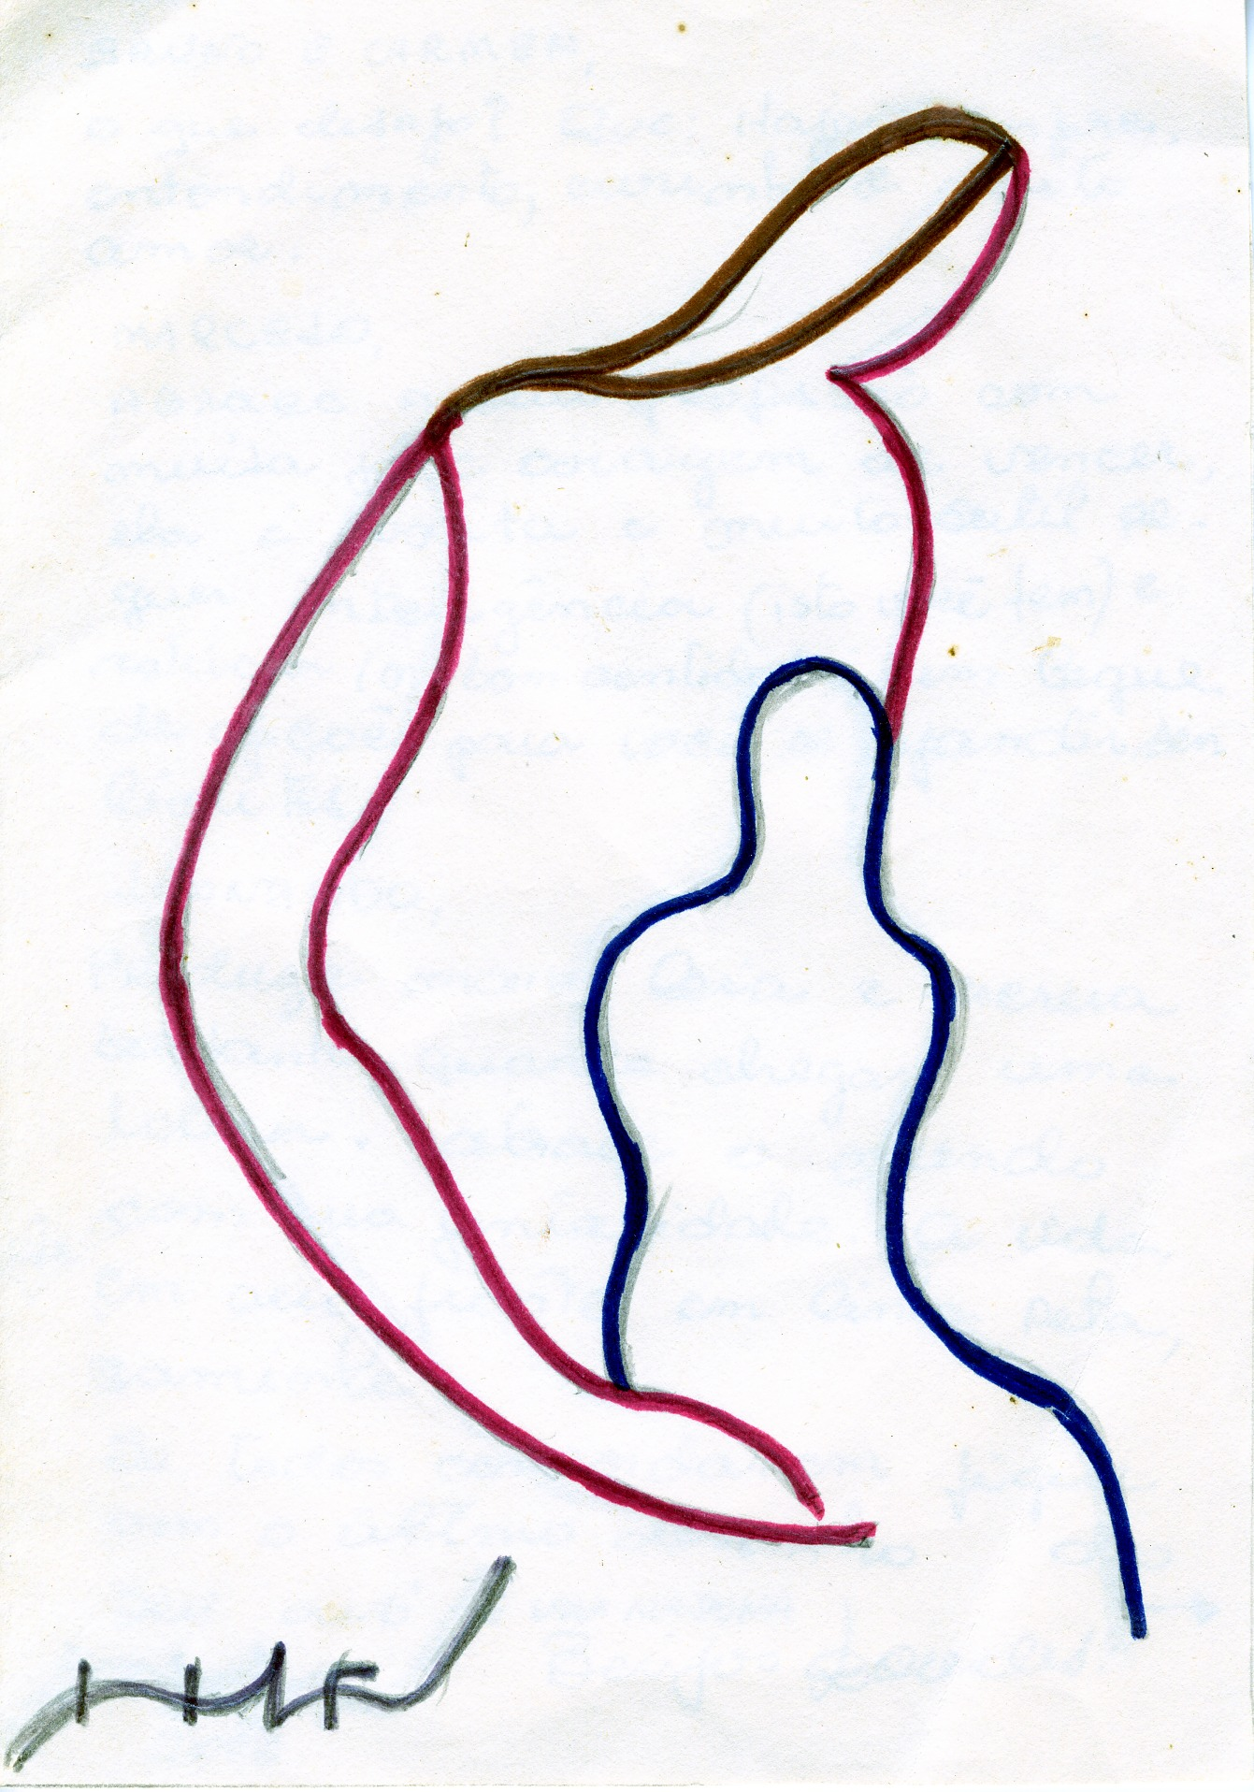
Figure 2: Example of image

In order to know if an image has sufficient resolution to be faithfully reproduced, you should multiply the size in cm by the factor 120. For example, an image of 5 cm x 7.5 cm in your document should have a resolution of no less than 600 pixels x 900 pixels. Another example: a screenshot of your entire 1024 x 768 display monitor should be no larger than 8.5 cm x 6.4 cm when positioned in your document.

Table titles should be centered above the tables.

3. Conclusion

The final sections of your work are: acknowledgements and references. These final sections are not numbered.

Acknowledgements

The authors would like to thank …

References

Woodcock, S., 2001. Game AI: the state of the art industry 2000-2001. Game Developer, 8 (8), 36-44.

Holland, M., 2004. Citing references: the Harvard System [online] Bournemouth University. Available from: www.bournemouth.ac.uk/library/using/harvard_system.html [Accessed 17 June 2006].

Kartch, D., 2000. Efficient rendering and compression for full-parallax computer-generated holographic stereograms. PhD thesis, Cornell University.

Parke, F.L. and Waters, K., 1996. Computer facial animation. Wellesley: AK Peters.

Ducheneaut, N., Yee, N., Nickell, E. and Moore, J.R., 2006. “Alone together?”: exploring the social dynamics of massively multiplayer online games. In: Proceedings of the SIGCHI conference on Human Factors in computing systems, 22-27 April 2006 Montreal. New York: ACM Press, 407-416.

